MLB Scouting Improvements
A First Round Draft Results Analysis
Lukas Nitsche

In recent years, there has been a feeling or sentiment that the players drafted to the MLB have been more successful, often making it to the MLB faster, and making a difference on their rosters sooner than in previous years. The 2024 draft alone has already seen 6 of the first 10 overall picks make their MLB debuts, and more multi-year contract extensions are being given out to unproven talents than ever, showing teams’ confidence in their prospects’ abilities. Players like Paul Skenes and Nick Kurtz have taken themselves from touted prospects to being mentioned amongst the MLB’s best without question, and with good reason.
However, this still begs the question of whether these success stories are a new norm, or if these players are just among a long list of success stories in what is largely the “crap shoot”, that is, the MLB draft. Has MLB amateur scouting actually improved, or are we just seeing the best-of-the-best players make a difference right after the draft, while others struggle to reach the highest level of baseball? In this report, I will study the past 25 years of MLB drafts pulled from Baseball Reference, to hopefully answer that question, and compare how well certain types of players have fared in this question.
Defining a Flop
This is where my definitions WILL get a little bit testy. I need to make some assumptions and definitions of what I deem as a 'flop' for a first-round draft pick. Firstly, any player drafted in the 2020 draft or later will not be identified as a flop, since players drafted out of high school have only played in the minors for at most 5 years, which puts them around age 23 at most in 2026, and the average debut age is between 23 and 25 for such players. Now, I will preface this by saying that just because a player is a flop does not mean they didn't have a good MLB career; it's just that they didn't live up to what was expected of a first-round talent.
If a player hasn't made their MLB debut, while being drafted pre-2020, I have deemed them a flop. Even with the 2019 draft class, the impact these players could have made at this point puts them already behind the curve, and otherwise, 25+ year-olds in the minor leagues will typically stay there. Therefore, I will also identify those not made their debut at 25 (typically older than the average MLB debut) as a flop. This is where it gets a little bit more difficult to identify, and some may argue this. If a college-drafted player has below a 0.3 WAR on average, then he is a little worse than a career bench player (on average), worse than what is expected of a first-round pick. The same goes for high school draftees with under a 0.2 yearly WAR. Also, if the player has a short career (below 5 years), he is also a 'flop'. The 'flop' variable will be used to see how successful a draft class is, in its entirety.
Of course, this definition is unfortunate when it comes to grading recent drafts, since players need time to develop. Furthermore, a few years of zero-flop drafts would throw the data off and make it look like MLB scouts have been flawless in the last few seasons.

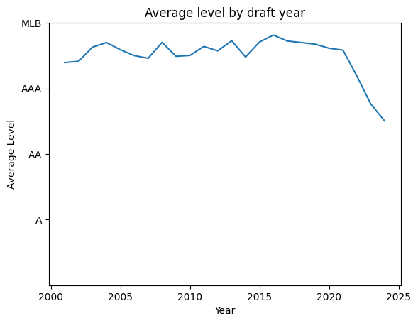
Highest Levels Reached
First, I will look at the highest MLB levels reached. I have assigned a numerical level to each level reached, 4 being MLB, 3 being AAA, 2 being AA, 1.66 being high-A, 1.33 being A, and 1 being low-A.

As we can see from this visualization, the more recent years don’t have as high a level reached, but this is to be expected. Recently drafted players don’t have the development time yet, so some players, specifically those drafted out of high school, are likely still in the low minor leagues.
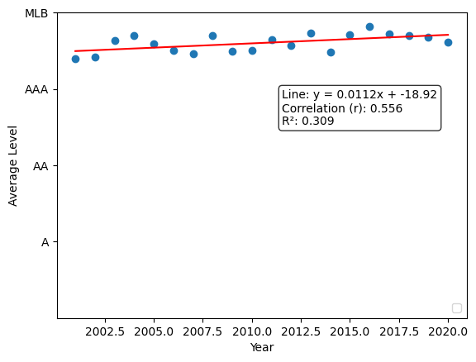
Up until 2018, or so, there does seem to be a gradual increase in the level the draftees have reached.
With a slope of 0.0112, we can see that there is some correlation with significance that the highest level reached for first-round picks is actually increasing. However, the level a player has reached doesn’t tell the full story. There are many players, like Aaron Judge, Justin Verlander, and Mike Trout, first ballot Hall of Famers, that have the same value in this category as players who were just up for ‘a cup of coffee’, as the saying goes.

WAR by Draft Year

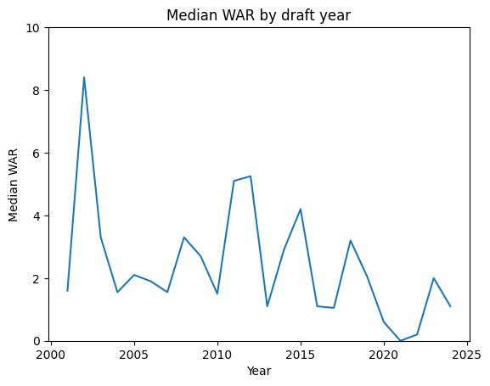
We can better get an understanding of how each draft is distributed with its players by looking at box plots for each. The players that are outliers are, for the most part, well-known big leaguers, with some being extraordinarily good players, like the aforementioned Aaron Judge, Justin Verlander, and Mike Trout. You can get a better idea of what this looks like by looking at the attached .ipynb file. However, the overall success of a draft can be looked at through the median WAR of a player drafted in a year:

Here we see the median WAR by draft year, with standouts being in 2002, 2011, and 2012. These successful drafts don’t necessarily contain the best players drafted in this time period, but have a lot of players fans will look on fondly as having good careers, such as Prince Fielder, Brandon Nimmo and Kevin Gausman.
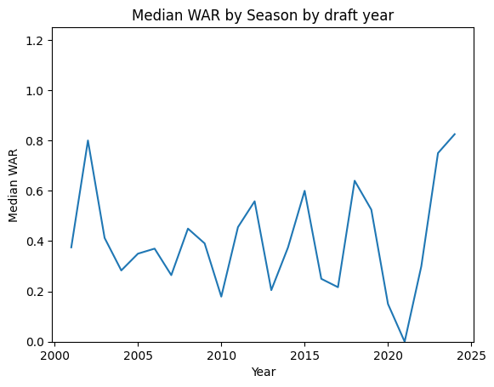
Turning to the median WAR by season, we see the typical topsy-turvy nature of how MLB drafts tend to look like without a clear pattern.

The seasonal WAR numbers all fall between 0 and 0.9, which is what is expected of a bench player in the MLB, but to say that a first-round talent is expected to amount to that level of play is an understatement.
High School and College Draftees
There is also an important difference to look at when comparing draft classes, which is looking at the high school versus college talent drafted. College players are seen as the safer options to pick, since these players are often more mature and have used their four years (give or take) to develop as players under the mentorship of high-level coaching. High school talents, although being scouted on a similar scale, can develop quirks between the ages of 18 and 23, an age where players will normally debut in modern baseball, leading to more nonlinear paths to the MLB, if they make it that far.
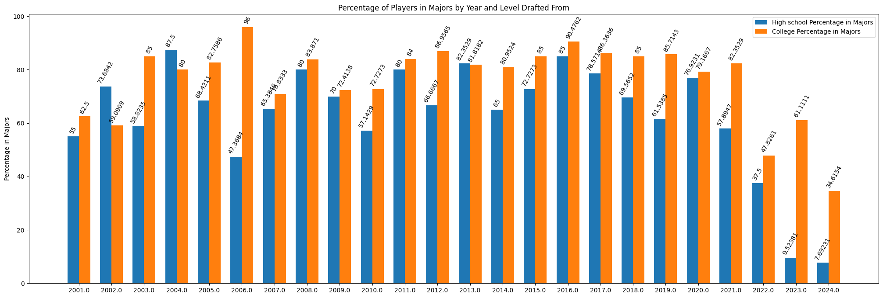
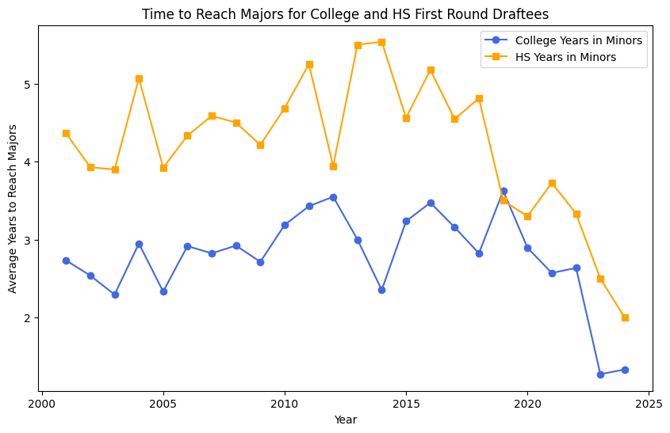
This is apparent from the graph above, with college draftees reaching the majors more often in all but three of the drafts I chose to look at. In the years since 2020, we also get an idea of how fast the college draftees make the majors by the gap between the percentage of college players in the league, compared to their younger counterparts. This point is echoed by the graph on the left, showing the lone year where high school players took less time being 2020.

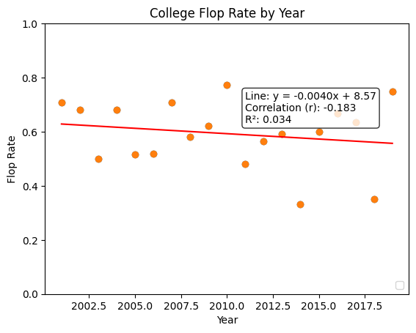
When we see the college flp rate by year, we actually see a small decline in the number of players that flop on a year-to-year basis in the draft, indicating a slight improvement in scouting at the college level. However, this slope of -0.004 only means that .4% less players are flopping every given draft class. If we estimate 55-60% of players are drafted from college in a draft of 40 players, college players only account for 24 of the total first round draft picks. For a given draft, this means that one fewer player is expected to be a flop, only once every 6 years or so, which would not be all that insignificant of a decrease, contrary to what the number may seem like.
Of course, the human element of baseball recruitment adds a further element. Teams can perfect a process to identify the ideal candidate to make a difference in their organization, and the player could be developing as planned, but has their career derailed by an injury, or they choose something else. This is the case with the Oakland Athletics 2018 first round pick, Kyler Murray, who chose to play football, despite having a case to play baseball to a high level as well.
Breakdown by Position
Moving on to the breakdown of success by position, we see the difference between the flop rate of pitchers and hitters. Typically, college pitchers are seen as the safest option, since velocity, pitch type, and shape has matured to a point that is big-league ready, where as hitters coming from the same level to grow into the major league level more.
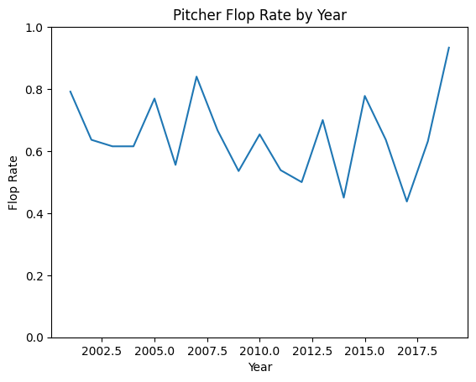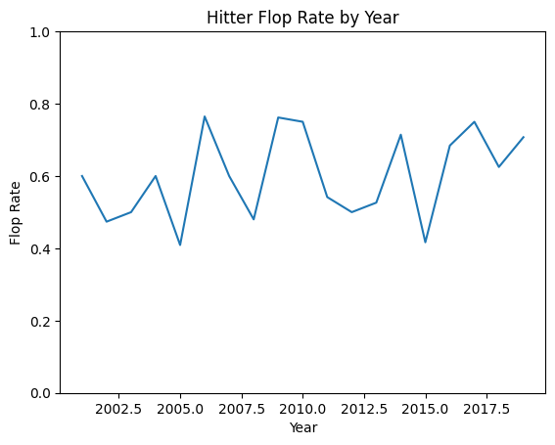
However, judging by these two graphs, we seem to notice the opposite. Why is this the case? Maybe, some high school pitchers are throwing off the numbers for the college numbers, or some other factor
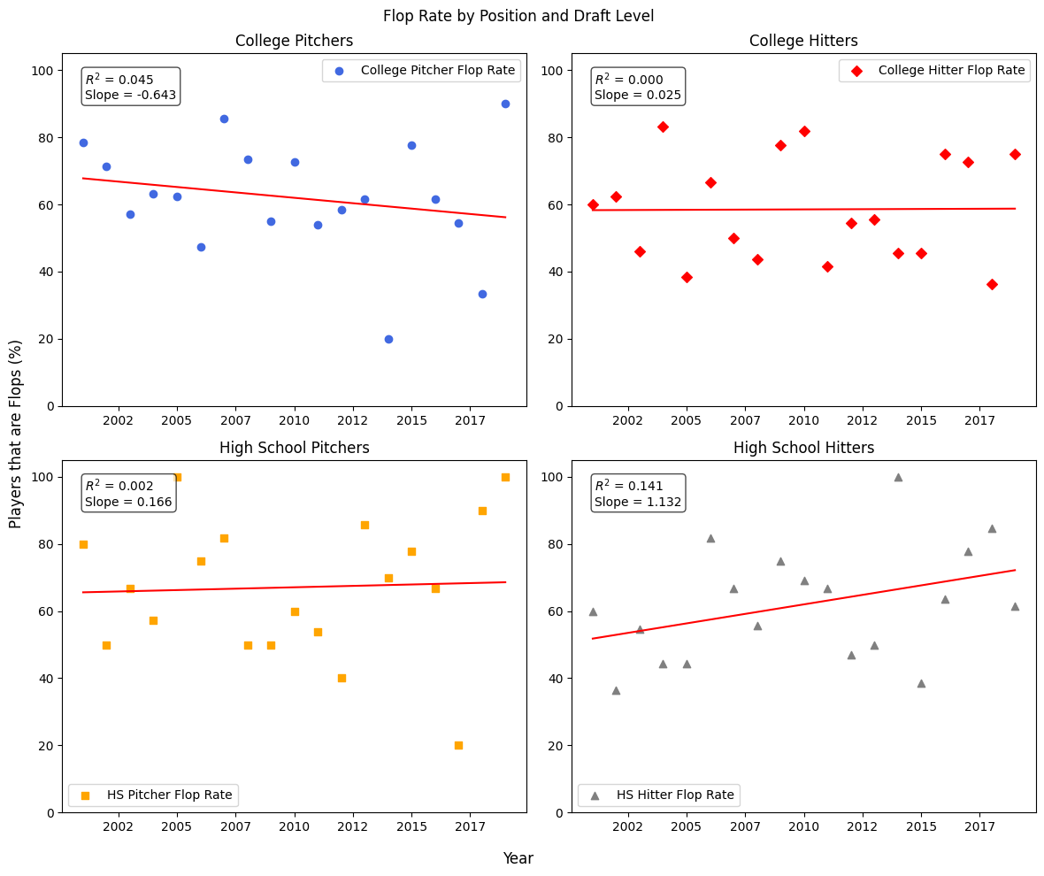
.
The expected decrease in flop rate is seen here for college pitchers is seen here, but the overall flop rate is still around 60% for the position. What is interesting to note is he increase of flop rate for high school hitters. This category of players is the only one that has a significant increase in the flop rate for first round draftees. Some of the drafts at the start of the time period include players such as Joe Mauer in 2001, Zack Grienke, Cole Hamels and Matt Cain in 2002, Niel Walker and Gio Gonzales in 2004 and Justin Upton, Andrew Mccutchen and Colby Rasmus in 2005. These four years of drafts had exceptionally low flop rates for high school pitchers, whereas recent years haven’t seen as successful of drafts from the same level. Recent draftees out of high school such as Jackson Holliday, Jackson Jobe, Marcelo Meyer and Robert Hassell III have struggled to make an instant impact. In fact, since the 2019 draft, in which Bobby Witt Jr, CJ Abrams, Corbin Carrol and Anthony Volpe, a quartet that has tallied 65.2 total WAR since the date of their drafting, only Pete Crow Armstrong, Jackson Merril, Colson Montgomery and Kevin McGonigle stand out as touted names in the MLB. I will caveat that a majority of these players still have time to develop, and can improve, but scouts seem to have strayed from drafting any high school hiters.
College pitchers in recent years have felt like the most significant source of instant impact talent, with Paul Skenes leading the line, recent debutants such as Trey Yesavage and Cade Horton making noise, and prospects such as Kade Anderson and Liam Doyle already moving up prospect rankings only a year after being drafted. However, as is true for any prospect being drafted, success isn’t guaranteed. For every Paul Skenes, Chris Sale and Max Scherzer that is drafted out of college, there are stories for players such as Kyle Sleeth, who underwent two Tommy John surgeries in back-to-back seasons, and never reached the big leagues, and was forced to retire from professional play. This also doesn’t include the amount of players that went on to have below-average MLB careers, pitching in bullpens and filling in 4A spots, splitting time between AAA and MLB levels when injuries occur.
Conclusion
Overall, we may have seen some slight improvements in MLB scouting, but the recent feeling might not be more than the best-of-the-best prospects reaching the league at a pace that is expected of them. Colleges are doing a better job preparing players for the big leagues, and the level of competition in baseball in college and high school has improved greatly in recent years. Pitcher velocities are trending up, and hitters are having to adapt to these speeds. However, this doesn’t necessarily lead to success for all players at the big league level. Paul Skenes and Dylan Crews were two of the most MLB-ready players drafted in the 2023 draft, and while Skenes has thrived, Crews has spent multiple stints at the MLB level with the Washington Nationals, struggling at times to leave a real impact. Some of the fastest call ups, such as Chase Burns, Nick Kurtz, Wyatt Langford and Paul Skenes have changed their franchises, and returned themselves likely big-money contract extensions. Other players have already received these extensions while playing in the minors, showing teams’ trust in knowing what they have, trusting the players will develop into what is expected of them.
Although these successes headline MLB scouting reports, there are still going to be the failures due to the human factor for all of these players. Some 5-tool players might look amazing on paper, but injuries, or even mental sruggles to amount to what is expected of them, has led many players ot never reach the big league level, and no matter how perfect a process towards big league development might be for the average draftee, they may never reach the level they strive for.

